
Weight of bags
600g
600g
800g
250g
400g
1kg
200g
500g
TOTAL: 4.35Kg

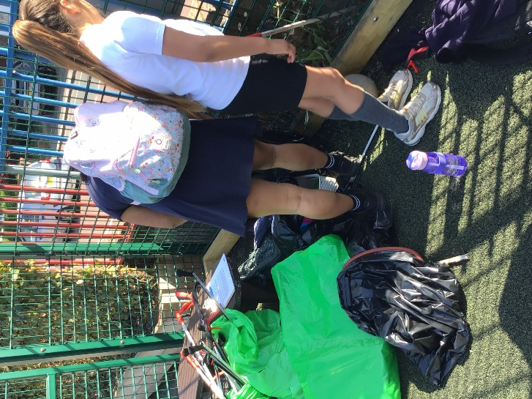

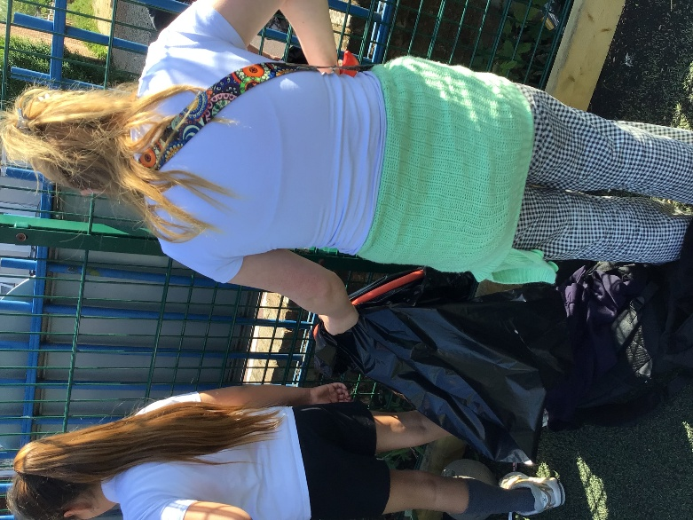

Thank you to all the staff and families who came to help!

